POLLUTION MONITORING SYSTEM USING IOT

PROJECT DONE BY

|  |  |  |  |
| --- | --- | --- | --- |
| **NAME** | **BRANCH** | **YEAR** | **COLLEGE** |
| Ketaki Subhash Nanaware | E&TC | SE | AISSMS COE, Pune-01 |
| Anjana Ramesh Nambiar | E&TC | SY | Vishwakarma Institute of Information Technology, Kondhwa,Pune |
| Sahil Jaywant Gole | Electrical | TY | AISSMS COE, Pune-01 |
| Prasad Khade | E&TC | TY | Vishwakarma Institute of Information Technology, Kondhwa,Pune |

INDEX

|  |  |  |
| --- | --- | --- |
| **SR. NO.** | **TITLE** | **PAGE NO.** |
| 1. | Abstract | 3 |
| 2. | Introduction | 3 |
| 3. | Components used | 5 |
| 4. | Architecture | 11 |
| 5. | Code |  |
| 6. | Results |  |
| 7. | Application |  |
| 8. | Future scope |  |
| 9. | Conclusions |  |
| 10. | References |  |

**ABSTRACT**

The problem of air pollution is a very crucial problem that has been encountered lately. Air pollutants in the atmosphere like CO, CO2, SO2, NO2, and O3, and volatile organic compounds are having a great effect on the people health. Most of the major cities in developing and the developed countries are suffering from it. Therefore there is a need to develop an air quality and pollution monitoring system. The innovation grasped here, is a hands-on execution of the idea of Internet of Things (IoT). We have developed an Arduino based air pollution monitoring system. The advantages of the detector, have a reliable stability, rapid response recovery and long-life features. It is affordable, user-friendly, low-cost and minimum-power requirement hardware which is suitable for mobile measurement, as well as comprehensible data collection.

**INTRODUCTION**

Air pollution is a major global environmental risk to our health and food security. It is estimated to cause about 3.7 million premature deaths worldwide and destroys enough crops to feed millions of people every year. The rapid industrialization, fast urbanization , rapid growth in population, drastic increase in vehicles on roads and other activities of human beings have disturbed the balance of natural atmosphere. It changes the quality of climate and those climate change is brought about by the accumulation of greenhouse gases in the atmosphere. One of the greatest environmental problem facing the world today is global warming caused by emission of greenhouse gases. Carbon dioxide, which is an important constituent of environment is causing a warming effect on the earth’s surface. To save our environment, monitoring and controlling these changes is a big challenge. Sulfur dioxide and nitrogen oxide particles in the air can create acid rain when they mix with water and oxygen in the atmosphere. These air pollutants mostly come from coal-fired power plants and motor vehicles. When acid rain falls to Earth, it damages plants by changing soil composition; degrades water quality in rivers, lakes and streams; damages crops; and can cause buildings and monuments to decay.

Health officials, the general public and farmers need advance notice when dangerous air quality levels are on the rise. The main objective of this project is to develop an IOT BASED air quality monitoring system with the help of Arduino. Also, it can be implemented as a smart system for early detection of forest fires or wild fires. Wild fires, are uncontrolled fires occurring in wild areas and cause significant damage to natural and human resources and they emits a huge amount of CO2 gas .

We propose an air quality as well as air pollution monitoring system that allows us to monitor and check live air quality as well as air pollution in an area through Internet of Things (IoT). It uses air sensors (Gas sensor MQ135 , Gas sensor MQ 7) to sense presence of harmful gases/compounds in the air and constantly transmit this data. The sensors interact with Arduino Uno (Microcontroller) which processes this data and transmits it over the application. This allows authorities to monitor air pollution in different areas and act against it.

IOT:

The Internet of Things (IoT) is an emerging technology, the interconnection of embedded computing devices within the existing Internet infrastructure which allows direct device to device communications. The IoT concerns the connection of physical device to the Internet. It interfaces these autonomous devices to communicate quickly without any human intervention and generates integrated data. The system consists of sensors, an arduino board, an IDE (Integrated development environment and an user interface module. In IoT, applications, services, middleware components, networks, and end nodes are structurally planned and used in entire new ways. The number of IoT-connected devices grew by 8 percent in 2021 and is projected to leap by another 22 percent through 2025, reaching 27 billion devices, according to market research platform IoT Analytics.

Examples of the Internet of Things span industries, from manufacturing and automotive to healthcare and retail. Though it has a great versatility, there are still many problems to be solved, such as low power computing, low cost and low latency communication, identification and positioning technologies, self-organized distributed systems technology, and distributed intelligence.

AIR QUALITY INDEX:

The Air Quality Index (AQI) is used for reporting air quality. It tells you how clean or polluted your air is, and what associated health effects that might be a concern for you. The Environmental Protection Agency (EPA) calculates the AQI for five major air pollutants, for which national air quality standards have been established to safeguard public health.

1. Ground-level ozone

2. Particle pollution/particulate matter (PM2.5/pm 10)

3. Carbon Monoxide

4. Sulfur dioxide

5. Nitrogen dioxide

PPM is commonly used in measuring air, water and body fluids pollution. PPM is the mass ratio between a component and a solution.

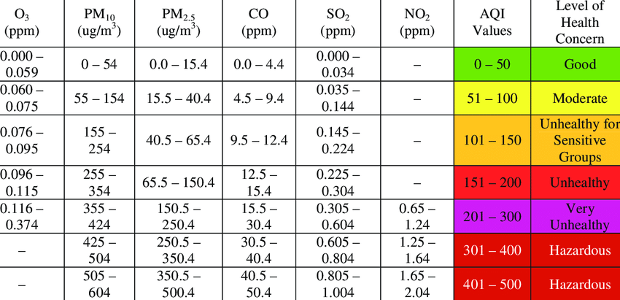

**COMPONENTS USED**

1) Arduino UNO

2) Gas sensor MQ 135

3) Gas sensor MQ 7

4) DHT 22 sensor

5) I2C Serial interface adapter

6) LCD

7) Breadboard

8) Jumper Wires

1) Arduino UNO:

It is the core of our project. Arduino is an open source, computer hardware and software company, project, and user community that designs and manufactures single-board microcontrollers and microcontroller kits for building digital devices and interactive objects that can sense and control objects in the physical world.

The Arduino UNO includes input/output pins, a USB connector, a power jack, and an ICSP (In-Circuit Serial Programming) header. It is programmed based on IDE, which stands for Integrated Development Environment. It can run on both online and offline platforms.

Arduino UNO is based on an ATmega328P microcontroller. It is a single chip Microcontroller of the ATmel family. The processor code inside it is of 8-bit. It combines Memory (SRAM, EEPROM, and Flash), Analog to Digital Converter, SPI serial ports, I/O lines, registers, timer, external and internal interrupts, and oscillator. There are 20 Input/Output pins present on the Arduino UNO board. These 20 pins include 6 PWM pins, 6 analog pins, and 8 digital I/O pins. The PWM pins are Pulse Width Modulation capable pins. The crystal oscillator present in Arduino UNO comes with a frequency of 16MHz. The input voltage of the UNO board varies from 7V to 20V. Arduino UNO automatically draws power from the external power supply. It can also draw power from the USB.

With the availability of a large no. of source codes over the internet, the programming of Arduino becomes relaxed.

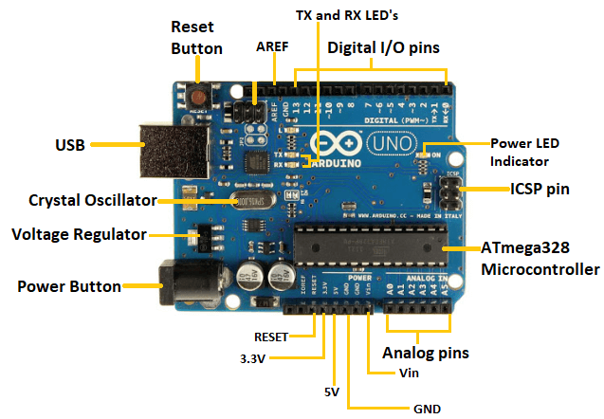

2) MQ 135:

The MQ-135 Gas sensor can detect gases like Ammonia (NH3), sulfur (S), Benzene (C6H6), CO2, and other harmful gases and smoke. Similar to other MQ series gas sensors, this sensor also has a digital and analog output pin. When the level of these gases go beyond a threshold, the digital pin goes high. This value can be set by using the on-board potentiometer. It operates from 2.5V to 5.0V and can provide both digital and analog output. The detection range is 10-10,000 ppm with the voltage rate of about 5.0V±0.1V AC or DC.

The digital output pin of the sensor can be used to detect harmful gases in the environment. The sensitivity of the digital pin can be controlled by using the potentiometer. If the gas is detected the indicator LED will turn on and the digital pin will go from logic high to logic low (0V). The LM393 Op-Amp Comparator IC is used to compare the actual gas value with the value set using the potentiometer. If the actual gas value increases than the set value then the digital output pin gets low.

The Analog output pin of the sensor can be used to measure the PPM value of the required gas. To do this we need to use an external microcontroller like Arduino. The microcontroller will measure the value of analog voltage and perform some calculations to find the value of Rs/Ro where Rs is the sensor resistance when gas is present and Ro is sensor resistance at clean air.

MQ135 gas sensor gives the output in form of voltage levels and needs to be converted into PPM. For that resistance of the sensor in clean air (R0) is to be measured. Measuring the resistance between the A0 pin and GND would give us the value of resistor R2. R0 here creates a voltage divider with R2.

Formula for R0:

R0= Rs (1-A0) /A0

The important features are long life span, low cost, simple driver circuit and good sensitivity to toxic gases.

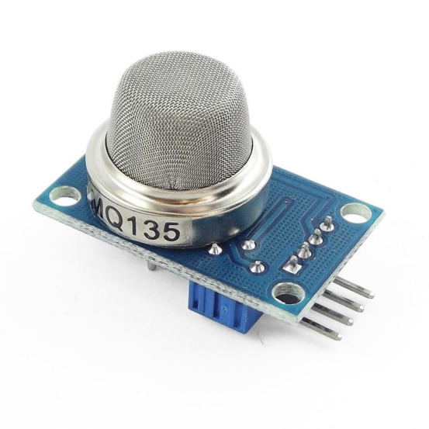

3) MQ 7:

MQ7 Gas sensor is another one of Metal Oxide Semiconductor (MOS) type Gas Sensor of MQ Gas Sensors family. It is mainly used to detect Carbon Monoxide. This sensor contains a sensing element, mainly aluminium-oxide based ceramic, coated with Tin dioxide (SnO2), enclosed in a stainless-steel mesh. Whenever CO gas comes into contact with the sensing element, the resistivity of the element changes. The change is then measured to get the concentration of the gases present. To use the Sensor Module, you have power the device with 5V supply and the Power LED will start to glow. To power it, you can use external supply or connect +5V and GND pin of Arduino. While measuring the gas present, the output LED will glow in a specific concentration of the gas. You can change it by using the potentiometer, else you can also use the analog output to see how your program reacts to different concentrations of gases present.

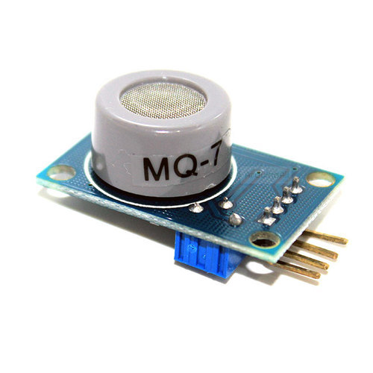

4) DHT 22:

The DHT22 is a basic, low-cost digital temperature and humidity sensor. It uses a capacitive humidity sensor and a thermistor to measure the surrounding air and gives a digital signal on the data pin (no analog input pins needed).

The operating voltage of the sensor is from 3 to 5V. The operating range is 0-100% RH for humidity and 40-80 Celcius for temperature.

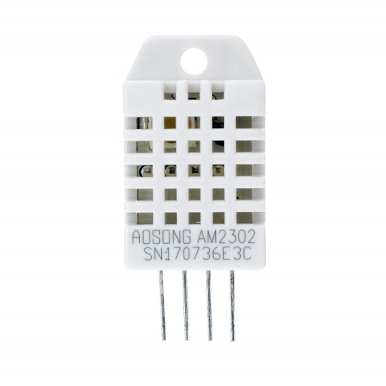

5) I2C Serial interface adapter :

I2C is short for Inter-IC. I2C is a synchronous, multi slave, multi master packet switched, single-ended serial bus. The I2C serial interface adapter is also known as I2C Module. It has total of 20 male pins. 16 pins are faced to rear side and 4 pins faced towards front side. The 16 pins for connect to 16x2 LCD and the 2 pins out of 4 pins are SDA and SCL. SDA is the serial data pin and SCL is the clock pin. The rest 2 pins for power supply (VCC and ground). There is a POT on the I2C Module. We can control the contrast of the LCD display by rotating this POT. And there is a jumper fixed on the module. When we remove the jumper, the backlight of the LCD display will go OFF.

There are three solder pads on the I2C module which is labelled as A0, A1 and A2. This is Address selectors. i.e, each solder pads have one upper potion and a one lower potion. If there is a connection between upper potion with lower connection, it is called "Connected" otherwise it is called "Not connected". In default; the A0, A1, A2 are in "Not connected" condition.

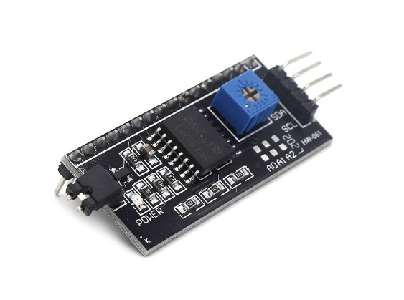

6) LCD:

LCD (Liquid Crystal Display) screen is an electronic display module, a very basic module and is very commonly used in various devices and circuits. These modules are preferred over seven segments and other multi-segment LEDs. LCDs are economical, easily programmable, have no limitation of displaying special & even custom characters (unlike in seven segments), animations and so on. A 16x2 LCD means it can display 16 characters per line and there are 2 such line and every character will be made with 5×8 (40) Pixel Dots. So the total pixels within this LCD can be calculated as 32 x 40 otherwise 1280 pixels.

The pin configuration of the LCD is as follows:

Pin1 (Ground): This pin connects the ground terminal.

Pin2 (+5 Volt): This pin provides a +5V supply to the LCD

Pin3 (VO): This pin selects the contrast of the LCD.

Pin4 (Register Select): This pin is used to connect a data pin of an MCU & gets either 1 or 0. Here, data mode = 0 and command mode =1.

Pin5 (Read & Write): This pin is used to read/write data.

Pin6 (Enable): This enables the pin must be high to perform the Read/Write procedure. This pin is connected to the data pin of the microcontroller to be held high constantly.

Pin7 (Data Pin): The data pins are from 0-7 which are connected through the microcontroller for data transmission. The LCD module can also work on the 4-bit mode through working on pins 1, 2, 3 & other pins are free.

Pin8 – Pin 14 are all data pins.

Pin15 (LED Positive): This is a +Ve terminal of the backlight LED of the display & it is connected to +5V to activate the LED backlight.

Pin16 (LED Negative): This is a -Ve terminal of a backlight LED of the display & it is connected to the GND terminal to activate the LED backlight.

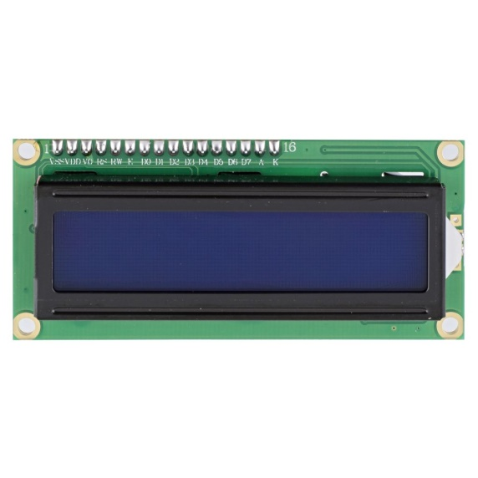

7) Breadboard:

A breadboard is a solderless device for temporary prototype with electronics and test circuit designs. Most electronic components in electronic circuits can be interconnected by inserting their leads or terminals into the holes and then making connections through wires where appropriate. The breadboard has strips of metal underneath the board and connect the holes on the top of the board. The metal strips are laid out as shown below. Note that the top and bottom rows of holes are connected horizontally and split in the middle while the remaining holes are connected vertically.

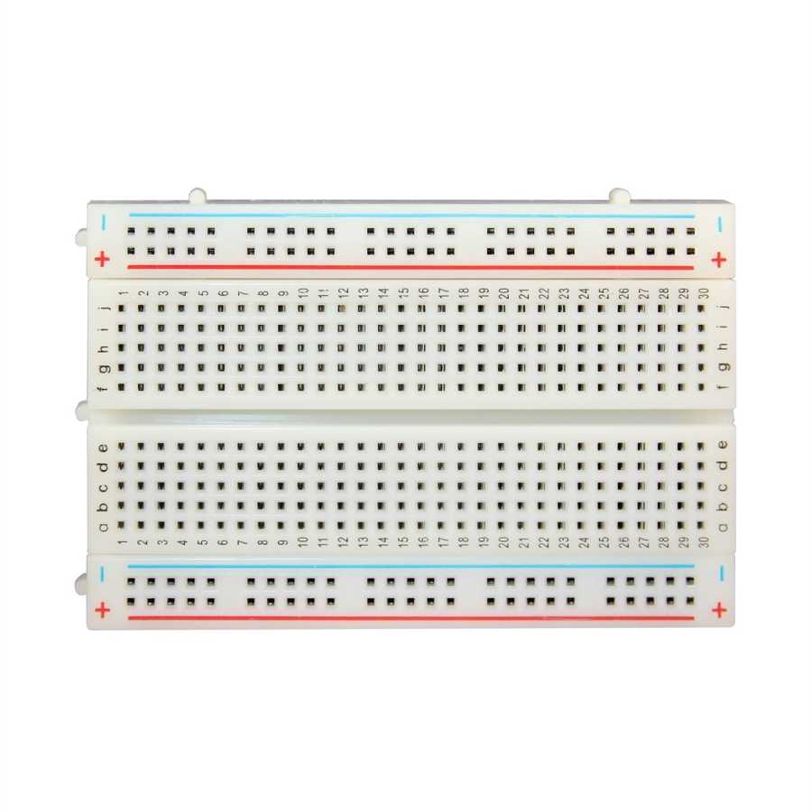

8) Jumper Wires:

Jumper wires are simply wires that have connector pins at each end, allowing them to be used to connect two points to each other without soldering. Jumper wires are typically used with breadboards and other prototyping tools in order to make it easy to change a circuit as needed.

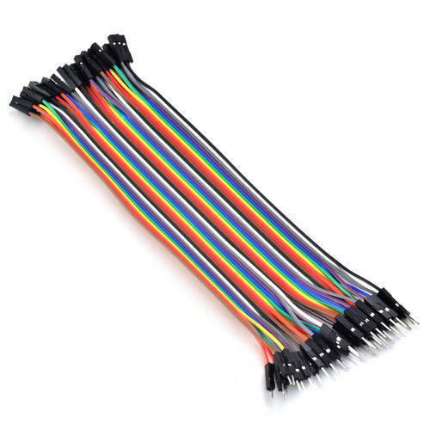

**ARCHITECTURE:**

The MQ 7 sensor is connected to the analog pin A0 of Arduino. The DHT 22 is connected to the Pin 7 and the MQ135 is connected to the A2 pin of the Arduino. All the VCC pins of the used components are connected to the VCC port of the Arduino and GND pins are grounded with the help of the GND port of the Arduino. The LCD will display the inputs taken by the sensors associated.

**BLOCK DIAGRAM**

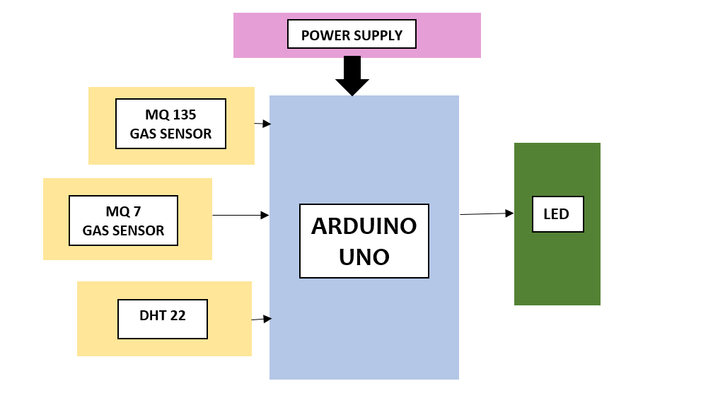

**CIRCUIT DIAGRAM**

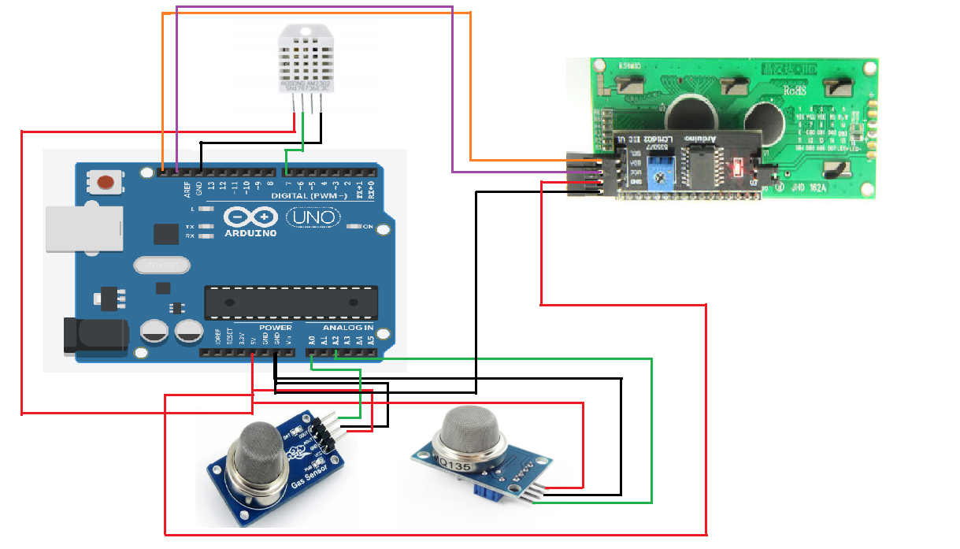

**CODE:**

#include <dht.h>

#include <LiquidCrystal_I2C.h>

#include "MQ135.h"

#define ANALOGPIN A2

#define RZERO 206.85 // RZERO Calibration Value

MQ135 gasSensor = MQ135(ANALOGPIN);

LiquidCrystal_I2C lcd(0x27, 16,2);

dht DHT; //Declaring the DHT as a dht type to use it later

#define DHT22_PIN 7 //pin defined

void setup()

{

lcd.begin (16,2);

lcd.backlight();

lcd.setBacklight(HIGH);

lcd.home ();

lcd.init();

Serial.begin(9600);

float rzero = gasSensor.getRZero();

delay(3000);

Serial.print("MQ135 RZERO Calibration Value : ");

Serial.println(rzero);

}

void loop()

{

int sensorValue = analogRead(A0); // print out the value you read:

Serial.print("carbon monoxide:");

Serial.println(sensorValue);

delay(1000);

lcd.clear();

lcd.setCursor(0,0);

int chk = DHT.read22(DHT22_PIN); //Reading data from the module

float t= DHT.temperature*(9/5) + 32; //Converting Celsius to Farenheit

lcd.print("Temp: ");

lcd.print(t); //Showing temperature value in Farenheit

lcd.print(" F");

lcd.setCursor(0,1);

lcd.print("Humidity: ");

lcd.println(DHT.humidity); //Showing humidity percentage

lcd.print(" %");

Serial.print("temp:");

Serial.println(t);

Serial.print("humidity:");

Serial.println(DHT.humidity);

delay(2000);

float ppm = gasSensor.getPPM();

delay(1000);

Serial.print("pollution in ppm : ");

Serial.println(ppm);

lcd.setCursor(0,0);

lcd.print("POLL.IN.PPM");

lcd.setCursor(0,1);

lcd.print("AIR QUA: ");

lcd.print(ppm);

lcd.print("PPM");

delay(2000);

}

**RESULT:**

The MQ135 sensor can sense CO2 and some other gases, so it is perfect gas sensor for my Air Quality Monitoring Detection System Project.

When connected to Arduino, it senses the gases and gives Pollution level in PPM (parts per million). MQ135 gas sensor gives the output in form of voltage levels is converted into PPM.



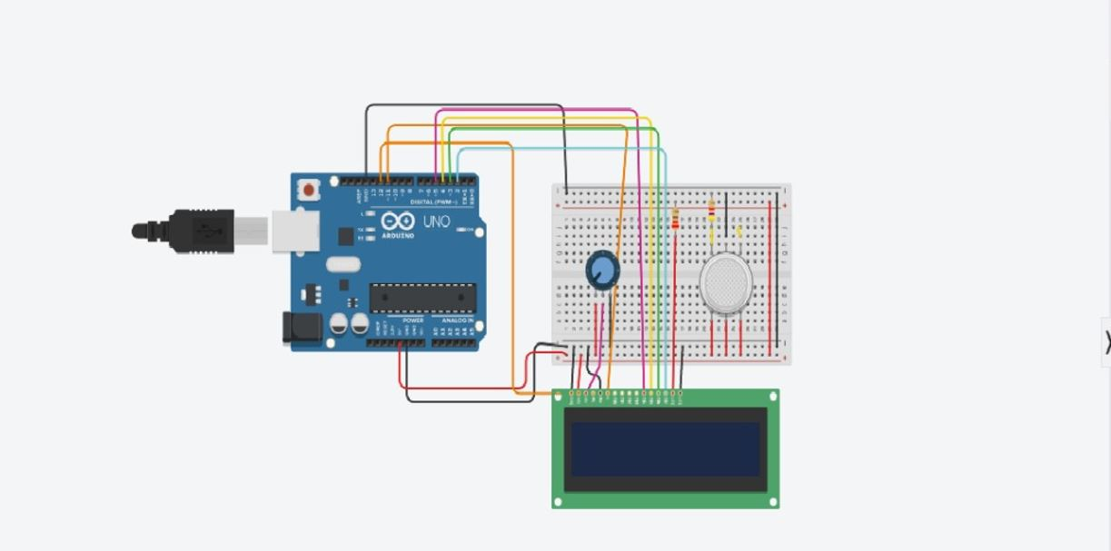

(The MQ7 sensor and the DHT22 sensor were not available on the tinkercad software)

**APPLICATIONS:**

1) Indoor Air Quality Monitoring System

It is quite shocking to know that more than 3.8 million people die annually due to indoor air pollution. The presence of particulate matter and harmful gases drops the quality of air, which when inhaled can cause severe diseases such as asthma, decreased lung function, and even cancer.

While the data pertains to both industrial as well as the commercial segment, the impact of air pollutants on workers is more due to the increased concentration of contaminants. The indoor air quality monitoring system thus helps companies to build a healthier working environment to keep the AQI under control.

By comparing the real-time air quality data with ideal conditions, companies can facilitate adequate ventilation, control the production of pollutants in their facility, and keep temperature & humidity level in a comfortable range.

2) Outdoor Air Quality Monitoring System

Environmental health has been a topic of discussion for decades. Different policies and regulations pertaining to the emission of pollutants in the air have been imposed to keep the air quality high. Hence, to keep the emission rate well under control as per the determined guidelines, it is important for industries to monitor the production of harmful gases.

By using outdoor air quality monitoring systems, companies can track the air quality index around their manufacturing units and subsequently control their emission rates. This helps them to adhere to regulations and prevent any lawfully enforced consequences from air quality administering organizations when air pollution levels exceed its limits.

3) Particulate Matter Monitoring

Particulate matter (PM) or Particulates are solid or liquid microscopic particles suspended in the air. Also known as aerosols, these particles are invisible to the naked eye and can be made up of different components like acids, metals, soil, dust, organic chemicals, etc. Since these particles are very small, they can be easily inhaled and affect health. The severity of the health issues is directly related to the size of these particles. Coarse PM that is generally found near highways or dusty industries ranges between 2.5 and 10 micrometers. However, the particles that are smaller than 2.5 micrometers are more dangerous since they can easily pass through the nose and throat and enter the lungs.

Controlling the creation of these particles during manufacturing or any other process is hence very important in industries since their continuous exposure can affect the health and performance of workers. By using a PM monitoring sensor along with air quality monitoring systems, companies can monitor the amount of particulate matter present in their facility. The sensor has a laser that scatters whenever particulates cross it. Based on the scattering of laser, the amount of PM in the air can be estimated.

4) Gas Detection System:

In industries like chemical and oil & gas, where harmful gases and toxins are either used or produced in or during manufacturing processes respectively, even a minor leakage can result in a catastrophe.

Working under the presence of H2S or SO2 for long durations can affect the respiratory system of the workers. Prolonged exposure can even affect mental health and cause severe headache, convulsions, nausea, or conjunctivitis. Also, leakage of combustible gases such as LPG or methane can result in explosions, causing injury to nearby operators and equipment damage. Moreover, oxygen displacing gases (also known as asphyxiants) such as methane or propane can reduce the concentration of oxygen level that can cause severe mental health issues and also death.

By using gas detection systems, the leakage of toxic and combustible gases can be detected and steps can be taken to roll-out the evacuation process, minimize equipment damage, and prevent their spread.

**FUTURE SCOPE:**

In this model, we can try to make modifications to make it more compact for portability. We can also use data loggers. Data loggers are electronic devices which automatically monitor and record environmental parameters over time, allowing conditions to be measured, documented, analysed and validated. The data logger contains a sensor to receive the information and a computer chip to store it. Then the information stored in the data logger is transferred to a computer for analysis. A GSM module can be connected in order to link your mobile phones to the device and get the information. Loggers in the Tinytag range monitor parameters including temperature, humidity, single and three phase power usage, CO2, mV, mA, voltage, pulses or counts.

**CONCLUSION:**

The developed model is used for detection of harmful gases present in the environment in order to get a previous alert.

Here, using the MQ135 gives the sense of different type of dangerous gas and Arduino is the heart of this project. Which control the entire process, Arduino module connects the whole process to LCD and serial monitor is used for the visual Output. Also, as we were increasing the no. of sensors the contrast settings for lcd was getting hampered i.e clear resolution was not there; solution being, to provide separate voltage source either only one of the sensors or Arduino.

The response time from mq 135 sensor was quite low

In a real time monitoring system; the system gives us data not just of the surrounding area, but all around the world. We can find out the air quality of any place we want to search for. For this purpose, an ESP module and a GPS system is also being integrated. The ESP is a low-cost Wi-Fi microchip with full TCP/IP stack and microcontroller capability. It is capable of either hosting an application or offloading all Wi-Fi networking functions from another application processor. Also, it can connect the elements used in the system to internet.

The GPS unit extracts the latitude and longitude of the polluted area whenever the signal is got from microcontroller. The GPS unit also sends data to the controller. The packet extracted through GPS includes date, time, latitude and longitude. Also, there is use of cloud database for accessing the required data by the user. A cloud database is a database that typically runs on a cloud computing platform, access to it is provided as a service.

To compare the model developed by us and the air monitoring system used at industrial level; here are some attributes:

|  |  |  |
| --- | --- | --- |
|  | Our developed model | Industrially developed model |
| Cost | Less costly | expensive |
| Accuracy | Less accurate | More accurate |
| Range of operation | Less | More |
| Specifications | Does not give detailed information due to usage of few components | Gives detailed analysed results due to usage of advanced tools. |
| Size | Small | Large |
| Installation | Easy | Difficult |

**REFERENCES:**

* Arduino-Based Real Time Air Quality and Pollution Monitoring System by Md. Abdullah Al Ahasan, Saumendu Roy, A. H. M. Saim, Rozina Akter, Md. Zakir Hossain
* IoT Based Air Pollution Detection Monitoring System with Arduino by Mursil Mahmud
* IoT-Based Real Time Air Pollution Monitoring System by Cynthia J., Kumaraguru College of Technology, Coimbatore, India; Saroja M.N., Kumaraguru College of Technology, Coimbatore, India ; Parveen Sultana, VIT University, Vellore, India; J. Senthil, Kumaraguru College of Technology, Coimbatore, India
* Poonam Pal, Ritik Gupta, Sanjana Tiwari, Ashutosh Sharma, “Air Pollution System Using Arduino”, International Journal on Information Theory (IJIT), Vol-04, Issue-10,2017;
* IOT Based Smart System for Controlling Co2 Emission by Dr . M. Newlin Rajkumar, Sruthi M. S , Dr . V. Venkatesa Kumar CSE, Anna University Regional Campus, Coimbatore, Tamilnadu, India
* www.arduino.cc
* https://www.ibm.com/blogs/internet-of-things/what-is-the-iot/
* http://www.airnow.com/